**DATA CHALLENGES FOR E-MOBILITY**

## A PROJECT REPORT

***Submitted by,***

**G. Akshay Kumar - 20211CSE0468**

**P. Mohammad Fayaz - 20211CSE0837**

**M. Lokesh Yadav - 20211CSE0479**

### *Under the guidance of,*

**Dr. Joseph Michael Jerard V**

***in partial fulfillment for the award of the degree of***

**BACHELOR OF TECHNOLOGY**

**IN**

**COMPUTER SCIENCE AND ENGINEERING**

**At**



**PRESIDENCY UNIVERSITY**

**BENGALURU**

**NOVEMBER 2024**

**PRESIDENCY UNIVERSITY**

**SCHOOL OF COMPUTER SCIENCE ENGINEERING**

**CERTIFICATE**

This is to certify that the Project report **“DATA CHALLENGES FOR E-MOBILITY”** being submitted by “G AKSHAY KUMAR, P MOHAMMAD FAYAZ, M LOKESH YADAV” bearing roll number(s) “20211CSE0468, 20211CSE0837, 20211CSE0479” in partial fulfillment of the requirement for the award of the degree of Bachelor of Technology in Computer Science and Engineering is a bonafide work carried out under my supervision.

|  |  |
| --- | --- |
| **Dr. Joseph Michael Jerard V**  PROFESSOR  School of CSE  Presidency University | **Dr. Asif Mohammad**  HoD  School of CSE  Presidency University |

|  |  |  |
| --- | --- | --- |
| **Dr. L. SHAKKEERA**  Associate Dean  School of CSE  Presidency University | **Dr. MYDHILI NAIR**  Associate Dean  School of CSE  Presidency University | **Dr. SAMEERUDDIN KHAN**  Pro-Vc School of Engineering  Dean -School of CSE&IS  Presidency University |

**PRESIDENCY UNIVERSITY**

**SCHOOL OF COMPUTER SCIENCE ENGINEERING**

**DECLARATION**

We hereby declare that the work, which is being presented in the project report entitled **DATA CHALLENGES FOR E-MOBILITY** in partial fulfillment for the award of Degree of **Bachelor of Technology** in **Computer Science and Engineering**, is a record of our investigations carried out under the guidance of **Dr.** **Joseph Michael Jerard V PROFESSOR,** **School of Computer Science Engineering, Presidency University, Bengaluru.**

We have not submitted the matter presented in this report anywhere for the award of any other Degree.

|  |  |
| --- | --- |
|  | **G Akshay Kumar – 20211CSE0468**  **P Mohammad Fayaz – 20211CSE0837**  **M Lokesh Yadav –20211CSE0479** |

**ABSTRACT**

The project title "Data Challenges for E-Mobility" focuses on creating a streamlined system to manage and improve the efficiency of electric vehicle (EV) infrastructure. The system comprises three modules: Admin, User, and EV Center. The Admin module allows administrators to log in, add EV charging centers, and address user complaints. Users can register, log in, and view nearby EV charging centers with location and calling options, ensuring convenience and accessibility. EV Center operators can log in to view and resolve complaints, enhancing service reliability. This project addresses key data management and operational challenges in the e-mobility sector. By fostering seamless communication between users, administrators, and EV centers, the platform ensures better service delivery and supports the adoption of sustainable EV solutions. It provides an innovative approach to tackle real-world issues in the growing field of electric mobility.

**Keywords :**

E-Mobility, Electric Vehicle (EV) Infrastructure, EV Charging Centers, Data Management, Complaint Resolution, Sustainable Mobility, User Accessibility, Service Efficiency, Electric Mobility Solutions, EV Adoption Challenges

**ACKNOWLEDGEMENT**

First of all, we indebted to the **GOD ALMIGHTY** for giving me an opportunity to excel in our efforts to complete this project on time.

We express our sincere thanks to our respected dean **Dr. Md. Sameeruddin Khan**, Pro-VC, School of Engineering, and Dean, School of Computer Science Engineering & Information Science, Presidency University for getting us permission to undergo the project.

We express our heartfelt gratitude to our beloved Associate Deans **Dr. Shakkeera L and Dr. Mydhili Nair,** School of Computer Science Engineering & Information Science, Presidency University, and Dr. “Asif Mohammad”, Head of the Department, School of Computer Science Engineering & Information Science, Presidency University, for rendering timely help in completing this project successfully.

We are greatly indebted to our guide **Dr.** **Joseph Michael Jerard V, PROFESSOR** and Reviewer **Dr. Naveen N M**, Assistant Professor School of Computer Science Engineering, Presidency University for his/her inspirational guidance, and valuable suggestions and for providing us a chance to express our technical capabilities in every respect for the completion of the project work.

We would like to convey our gratitude and heartfelt thanks to the PIP2001 Capstone Project Coordinators **Dr. Sampath A K, Dr. Abdul Khadar A and Mr. Md Zia Ur Rahman,** department Project Coordinators “Prof Srinivas Mishra” and Git hub coordinator **Mr. Muthuraj.**

We thank our family and friends for the strong support and inspiration they have provided us in bringing out this project.

**G Akshay Kumar**

**P Mohammad Fayaz**

**M Lokesh Yadav**

**LIST OF TABLES**

|  |  |  |
| --- | --- | --- |
| **Sl. No.** | **Table Name** | **Page No.** |
| 1 | Gantt Chart | 22 |
| 2 | Testing Cases | 31 |

**LIST OF FIGURES**

|  |  |  |  |  |
| --- | --- | --- | --- | --- |
| **Sl. No.** | **Figure Name** |  |  | **Page No.** |
| 1 | UML DIAGRAMS |  |  | 13 |
|  | 1.1 Class Diagrams |  |  | 13 |
|  | 1.2 Use Case Diagram |  |  | 14 |
|  | 1.3 Sequence Diagram |  |  | 15 |
|  | 1.4 Collaboration Diagram |  |  | 16 |
|  | 1.5 Activity Diagram |  |  | 17 |
|  | 1.6 Component Diagram |  |  | 18 |
|  | 1.7 Deployment Diagram |  |  | 19 |
|  | 1.8 ER Diagram |  |  | 20 |
| 2 | Data Flow Diagram |  |  | 20 & 21 |
| 3 | Architecture |  |  | 26 |
| 4 | Output Screenshots |  |  | 37 to 49 |
|  |  |  |  |  |
|  |  |  |  |  |
|  |  |  |  |  |

**TABLE OF CONTENTS**

|  |  |  |
| --- | --- | --- |
| **CHAPTER NO.** | **TITLE** | **PAGE NO.** |
|  | **ABSTRACT ACKNOWLEDGMENT**  **…** | **i**  **ii**  **…** |
| **1.** | **INTRODUCTION** | **1** |
|  | 1.1 Motivation | 1 |
|  | 1.2 Problem Statement | 1 |
|  | 1.3 Objective of the project | 1 |
|  | 1.4 Scope | 2 |
|  | 1.5 Project Introduction | 2 |
| **2.** | **LITERATURE REVIEW** | **4** |
|  | 2.1 Related Work | 4 |
| **3.** | **RESEARCH GAPS OF EXISTING METHOD** | **7** |
| **4.** | PROPOSED METHODOLOGY | 8 |
| **5.** | OBJECTIVES | 9 |
| **6.** | SYSTEM DESIGN & IMPLEMENTATION | 9 |
|  | 6.1 Introduction of Input Design | 9 |
|  | 6.2 UML Diagram (class, use case, sequence, collaborative, deployment, activity, ER diagram, and Component diagram) | 11 |
|  | 6.3 Data Flow Diagram | 20 |
| **7.** | TIMELINE FOR EXECUTION OF PROJECT | 22 |
| **8.** | ADVANTAGES & DISADVANTAGES | 23 |
| **9.** | REQUIREMENT & ANALYSIS | 24 |
|  | 9.1 Function and non-functional requirements | 24 |
|  | 9.2 Hardware Requirements | 25 |
|  | 9.3 Software Requirements | 25 |
|  | 9.4 Architecture | 26 |
| **10.** | SYSTEM STUDY AND TESTING | 26 |
|  | 10.1 Feasibility study | 26 |
|  | 10.2 Types of test & Test Cases | 28 |
| **11.** | FUTURE ENHANCEMENT | 32 |
| **12.** | CONCLUSION | 33 |

**CHAPTER-1**

**INTRODUCTION**

**1.1 Motivation**

The motivation behind this project stems from the growing need to support the transition to sustainable transportation through electric vehicles (EVs). As EV adoption accelerates, the efficiency and accessibility of charging infrastructure become crucial to ensuring widespread use. By developing a streamlined system for managing EV charging centers, the project aims to solve real-world challenges in service delivery and user convenience. Addressing these gaps will not only improve the user experience but also foster greater trust and confidence in electric mobility. Ultimately, the project contributes to the global goal of reducing carbon emissions and promoting greener transportation solutions.

**1.2 Problem Statement**

The electric vehicle sector faces significant challenges in managing and optimizing EV charging infrastructure. There is a lack of effective systems for connecting users with nearby charging stations, handling complaints, and ensuring operational reliability. The absence of a streamlined communication platform between users, administrators, and charging center operators results in inefficiencies, poor user experience, and delayed resolution of issues. As e-mobility adoption grows, addressing these gaps becomes critical to supporting sustainable mobility and enhancing the overall EV ecosystem.

**1.3 Objective of the Project**

The objective of this project, "Data Challenges for E-Mobility," is to create an efficient platform for managing and improving EV infrastructure. It focuses on streamlining data management by enabling administrators to add and monitor EV charging centers effectively. Users are provided with tools to locate charging centers, view details, and contact them directly for convenience. The platform ensures efficient complaint resolution by facilitating communication between users, administrators, and operators. By addressing these challenges, the project aims to enhance user satisfaction and operational reliability, promoting the adoption of sustainable e-mobility solutions.

**1.4 Scope**

The project aims to develop a comprehensive platform that enhances the management and efficiency of electric vehicle (EV) infrastructure by integrating three core modules: Admin, User, and EV Center. The system will facilitate seamless interaction between EV users, administrators, and charging center operators to improve service delivery, resolve complaints, and ensure accessibility to EV charging stations. It will address challenges related to data management, operational efficiency, and the growing demand for EV infrastructure. The platform also aims to foster greater adoption of electric vehicles through user-friendly features and better service reliability. This solution targets both current and future needs in the expanding e-mobility sector.

**1.5 Project Introduction**

The rapid growth of electric vehicles (EVs) is revolutionizing the automotive industry and contributing to global efforts for a sustainable, low-carbon future. As governments, organizations, and individuals increasingly adopt EVs, the demand for reliable and efficient charging infrastructure has surged. However, despite the growing popularity of electric mobility, the existing EV charging infrastructure faces significant challenges in terms of accessibility, reliability, and user experience. These issues, if left unaddressed, can hinder the widespread adoption of electric vehicles and delay the transition to greener transportation solutions. The project, titled "Data Challenges for E-Mobility," seeks to address these challenges by creating a comprehensive platform to streamline the management and operation of EV charging centers. The platform consists of three key modules: Admin, User, and EV Center. The Admin module allows administrators to manage the platform, add new charging stations, and resolve user complaints. The User module enables EV owners to register, log in, and easily locate nearby charging stations, while also providing options for direct communication with the charging centers. The EV Center module allows operators to view and resolve user complaints, ensuring a seamless and efficient service experience.

By bridging the gap between EV users, charging center operators, and administrators, this system will improve service reliability, optimize charging station usage, and enhance overall user satisfaction. The platform also supports better data management, making it easier to track and address issues related to charging stations. Ultimately, the project aims to foster greater adoption of electric vehicles, contributing to the global effort to combat climate change and promote sustainable mobility solutions. Through this approach, the platform provides an innovative solution to real-world challenges in the growing e-mobility sector.

**CHAPTER-2**

**LITERATURE SURVEY**

|  |  |  |  |  |  |
| --- | --- | --- | --- | --- | --- |
| **Author(s)** | **Title** | **Year** | **Journal** | **Key Features** | **Objective** |
| Chien, S., & Wei, C. | "A Mobile App-based Smart EV Charging Management System" | 2023 | Journal of Sustainable Transportation | Real-time data analysis, location-based services, predictive algorithms, load balancing, energy distribution, payment processing, user preferences. | Enhance user experience and optimize charging station performance, ensuring efficient energy distribution and grid load management. |
| Zhao, X., Liu, Y., & Wang, T. | "Intelligent Mobile App for EV Infrastructure Management and User Convenience" | 2022 | International Journal of Electric and Hybrid Vehicles | Intelligent routing, real-time status monitoring, dynamic pricing, scheduling, predictive algorithms. | Optimize charging infrastructure management and improve user convenience through dynamic scheduling, reduced wait times, and real-time insights. |
| Chen, R., & Zhang, M. | "Mobile-based Platform for Real-Time EV Charging Station Monitoring and Data Analytics" | 2021 | IEEE Transactions on Smart Grid | Real-time status, usage trends, energy consumption, reservation, payment, resource management. | Provide a comprehensive management solution for charging stations, improving resource allocation, maintenance, and user interaction. |
| Gupta, P., & Bansal, S. | "Optimizing EV Charging Stations with a Mobile Application for User Accessibility" | 2023 | Energy Reports | Real-time station availability, distance-based routing, predictive analytics, and user feedback. | Improve user accessibility, satisfaction, and network efficiency by minimizing wait times and enhancing energy distribution. |
| Patel, A., & Shah, N. | "Design and Development of an EV Charging Station Management System Using Mobile App Integration" | 2022 | Journal of Electrical Engineering & Technology | Real-time status, usage trends, energy consumption, reservation, payment, resource management. | Provide a comprehensive management solution for charging stations, improving resource allocation, maintenance, and user interaction. |

**CHAPTER-3**

**RESEARCH GAPS OF EXISTING METHODS**

**Existing System:**

Traditional complaint-handling systems rely on manual processes, making them time-consuming and error-prone. Standalone EV charging platforms and navigation apps focus on locating charging stations but lack features for real-time complaint resolution or communication. Dynamic charging management systems optimize station usage but neglect user-centric needs like feedback and issue tracking. Smart city complaint systems offer generalized solutions but fail to address e-mobility-specific challenges. These fragmented approaches highlight the need for an integrated platform that combines user accessibility, complaint resolution, and efficient administrative management tailored to the e-mobility ecosystem. This project addresses these gaps comprehensively.

**CHAPTER-4**

**PROPOSED METHODOLOGY**

The proposed system is a unified platform designed to streamline e-mobility management by integrating admin, user, and EV center functionalities. Administrators can add and manage EV charging centers while addressing user complaints efficiently. Users can locate nearby charging stations, access location details, and directly contact the centers for support. EV center operators can view and resolve complaints in real-time, ensuring service reliability. This system bridges the gaps in existing methods, providing a seamless, user-friendly, and efficient solution for managing e-mobility challenges.

**CHAPTER-5**

**OBJECTIVES**

The objective of this project, "Data Challenges for E-Mobility," is to create an efficient platform for managing and improving EV infrastructure. It focuses on streamlining data management by enabling administrators to add and monitor EV charging centers effectively. Users are provided with tools to locate charging centers, view details, and contact them directly for convenience. The platform ensures efficient complaint resolution by facilitating communication between users, administrators, and operators. By addressing these challenges, the project aims to enhance user satisfaction and operational reliability, promoting the adoption of sustainable e-mobility solutions.

**CHAPTER-6**

**SYSTEM DESIGN & IMPLEMENTATION**

**SYSTEM DESIGN :**

**6.1 Introduction of Input Design**

**INPUT DESIGN**

The input design is the link between the information system and the user. It comprises the developing specifications and procedures for data preparation and those steps are necessary to put transaction data into a usable form for processing can be achieved by inspecting the computer to read data from a written or printed document or it can occur by having people keying the data directly into the system. The design of input focuses on controlling the amount of input required, controlling the errors, avoiding delay, avoiding extra steps, and keeping the process simple. The input is designed in such a way that it provides security and ease of use while retaining privacy. Input Design considered the following things:

* What data should be given as input?
* How the data should be arranged or coded?
* The dialog to guide the operating personnel in providing input.
* Methods for preparing input validations and steps to follow when error occur.

**OBJECTIVES**

1. Input Design is the process of converting a user-oriented description of the input into a computer-based system. This design is important to avoid errors in the data input process and show the correct direction to the management for getting correct information from the computerized system.

2. It is achieved by creating user-friendly screens for the data entry to handle large volume of data. The goal of designing input is to make data entry easier and to be free from errors. The data entry screen is designed in such a way that all the data manipulates can be performed. It also provides record viewing facilities.

3. When the data is entered it will check for its validity. Data can be entered with the help of screens. Appropriate messages are provided as when needed so that the user will not be in maize of instant. Thus the objective of input design is to create an input layout that is easy to follow

**OUTPUT DESIGN**

A quality output is one, which meets the requirements of the end user and presents the information clearly. In any system results of processing are communicated to the users and to other system through outputs. In output design it is determined how the information is to be displaced for immediate need and also the hard copy output. It is the most important and direct source information to the user. Efficient and intelligent output design improves the system’s relationship to help user decision-making.

1. Designing computer output should proceed in an organized, well thought out manner; the right output must be developed while ensuring that each output element is designed so that people will find the system can use easily and effectively. When analysis design computer output, they should Identify the specific output that is needed to meet the requirements.

2. Select methods for presenting information.

3. Create document, report, or other formats that contain information produced by the system.

The output form of an information system should accomplish one or more of the following objectives.

* Convey information about past activities, current status or projections of the
* Future.
* Signal important events, opportunities, problems, or warnings.
* Trigger an action.
* Confirm an action.

**6.2 UML Diagram**

UML stands for Unified Modelling Language. UML is a standardized general-purpose modelling language in the field of object-oriented software engineering. The standard is managed, and was created by, the Object Management Group. The goal is for UML to become a common language for creating models of object-oriented computer software. In its current form UML is comprised of two major components: A Meta-model and a notation. In the future, some form of method or process may also be added to; or associated with, UML. The Unified modelling Language is a standard language for specifying, Visualization, Constructing and documenting the artifacts of software system, as well as for business modelling and other non-software systems. The UML represents a collection of best engineering practices that have proven successful in the modelling of large and complex systems. The UML is a very important part of developing objects-oriented software and the software development process. The UML uses mostly graphical notations to express the design of software projects.

The Unified Modelling Language (UML) serves as a standardized, general-purpose modelling language within the realm of object-oriented software engineering, overseen and created by the Object Management Group (OMG). Its primary objective is to establish a universal language for modelling object-oriented computer software, aiming to provide a common ground for software developers to communicate and collaborate effectively. UML consists of two main components: a Meta-model, which defines the structure and semantics of UML itself, and a notation, which encompasses the graphical symbols and diagrams used to represent various aspects of software systems. While currently focused on these components, UML may incorporate additional methods or processes in the future. As a standard language, UML facilitates the specification, visualization, construction, and documentation of software artifacts, along with applications in business modelling and other non-software domains. It encapsulates a collection of best engineering practices proven effective in modelling large and intricate systems. In the software development process, UML plays a pivotal role by enabling developers to express the design of software projects using graphical notations. Its adoption promotes clarity, consistency, and efficiency in communication, aiding in the development of robust and scalable object-oriented software systems. Thus, UML stands as a cornerstone in the development of object-oriented software and the broader software engineering process.

**GOALS:**

The Primary goals in the design of the UML are as follows:

1. Provide users a ready-to-use, expressive visual modelling Language so that they can develop and exchange meaningful models.
2. Provide extendibility and specialization mechanisms to extend the core concepts.
3. Be independent of particular programming languages and development process.
4. Provide a formal basis for understanding the modelling language.
5. Encourage the growth of OO tools market.
6. Support higher level development concepts such as collaborations, frameworks, patterns and components.
7. Integrate best practices.

**CLASS DIAGRAM:**

In software engineering, a class diagram in the Unified Modelling Language (UML) is a type of static structure diagram that describes the structure of a system by showing the system's classes, their attributes, operations (or methods), and the relationships among the classes. It explains which class contains information.

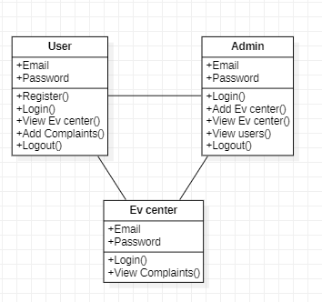

**USE CASE DIAGRAM:**

A use case diagram in the Unified Modeling Language (UML) is a type of behavioral diagram defined by and created from a Use-case analysis. Its purpose is to present a graphical overview of the functionality provided by a system in terms of actors, their goals (represented as use cases), and any dependencies between those use cases. The main purpose of a use case diagram is to show what system functions are performed for which actor. Roles of the actors in the system can be depicted.

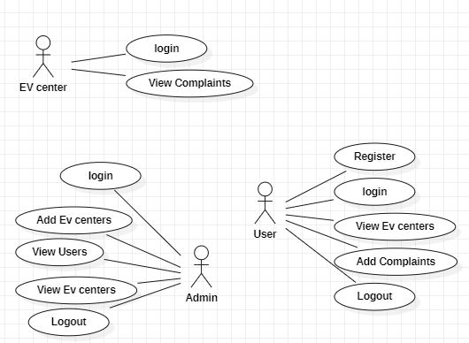

**SEQUENCE DIAGRAM:**

A sequence diagram in Unified Modelling Language (UML) is a kind of interaction diagram that shows how processes operate with one another and in what order. It is a construct of a Message Sequence Chart. Sequence diagrams are sometimes called event diagrams, event scenarios, and timing diagrams.

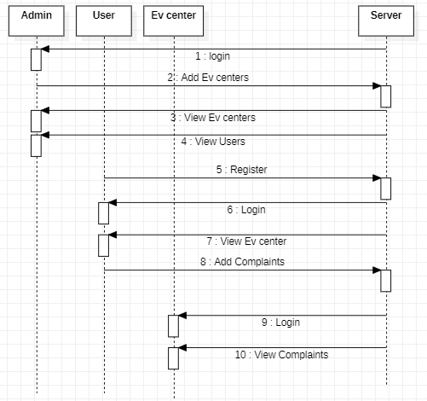

**COLLABORATION DIAGRAM:**

In collaboration diagram the method call sequence is indicated by some numbering technique as shown below. The number indicates how the methods are called one after another. We have taken the same order management system to describe the collaboration diagram. The method calls are similar to that of a sequence diagram. But the difference is that the sequence diagram does not describe the object organization whereas the collaboration diagram shows the object organization.

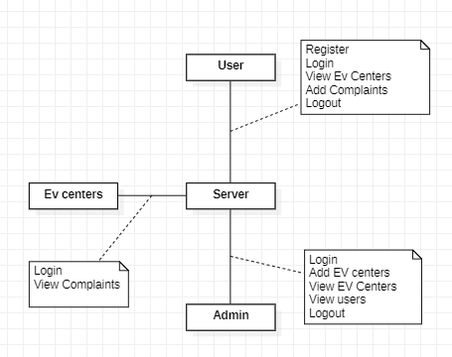

**ACTIVITY DIAGRAM:**

Activity diagrams are graphical representations of workflows of stepwise activities and actions with support for choice, iteration and concurrency. In the Unified Modelling Language, activity diagrams can be used to describe the business and operational step-by-step workflows of components in a system. An activity diagram shows the overall flow of control.

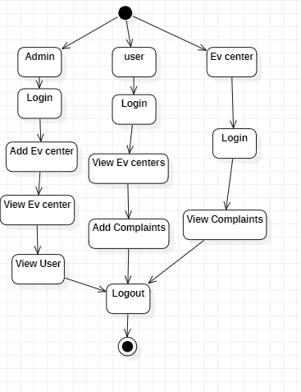

**COMPONENT DIAGRAM:**

A component diagram in software engineering illustrates the components of a system and their relationships. Components represent modular units of functionality, such as classes, modules, or libraries, and are depicted as rectangles with the component's name inside. Relationships between components are shown with lines connecting them, indicating dependencies, associations, or interfaces. Component diagrams help visualize the architecture of a system, including how components interact and communicate with each other. They are useful for understanding the structure of a software system and for communicating design decisions to stakeholders.

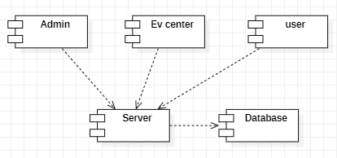

**DEPLOYMENT DIAGRAM:**

A deployment diagram in software engineering visualizes the physical deployment of software components onto hardware nodes in a distributed system. Nodes represent hardware devices, such as servers, computers, or mobile devices, depicted as rectangles with the node's name inside. Components, represented by rectangles with the component's name inside, are deployed onto nodes, showing how software elements are distributed across the hardware infrastructure. Deployment diagrams illustrate the configuration and deployment topology of a system, including the relationships between software components and the hardware resources they utilize. They aid in understanding system deployment and resource allocation in distributed environments.

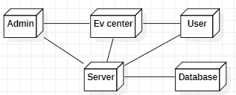

**ER Diagram:**

An Entity-Relationship (ER) diagram in database design illustrates the relationships between entities within a database schema. Entities represent real-world objects or concepts, such as customers, orders, or products, depicted as rectangles with the entity's name inside. Relationships between entities are shown with lines connecting them, indicating associations or dependencies. Cardinality and participation constraints may also be included to specify the nature of the relationships. ER diagrams help visualize the structure of a database schema, including the entities, attributes, and relationships between them. They serve as a blueprint for designing and implementing relational databases effectively.

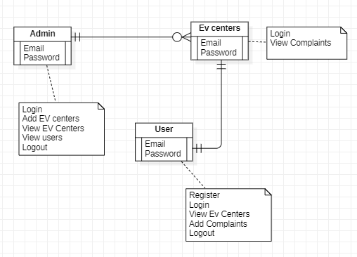

**6.3 Data Flow Diagram:**

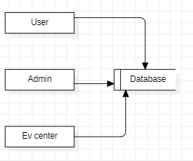

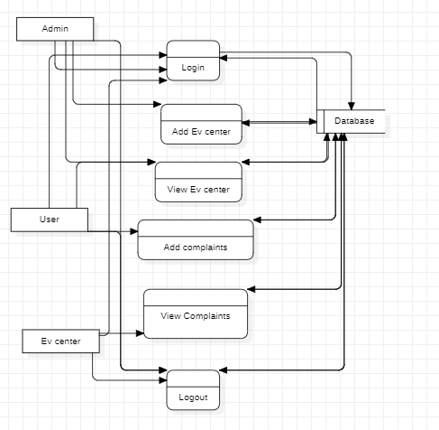

**IMPLEMENTATION :**

**6.4 Implementation**

**ADMIN**: The Admin module allows administrators to log in, manage the system, add new EV charging centers, and view customer complaints.

**USER**: The User module enables users to register, log in, and view available EV charging centers along with their locations. Users can also access a calling option for direct communication with charging centers.

**EV charging center**: The EV Center module is dedicated to the charging center staff, enabling them to log in, view user complaints, and manage their resolutions. This system enhances the user experience by providing an intuitive platform for both the management and usage of EV charging infrastructure, while also ensuring efficient handling of complaints.

**CHAPTER-7**

**TIMELINE FOR EXECUTION OF PROJECT**

**(GANTT CHART)**

|  |  |  |  |
| --- | --- | --- | --- |
| **TASK** | **Start Date** | **End Date** | **No. of Days** |
| **Research** | **07-sep-2024** | **18-sep-2024** | **11** |
| **Project Plan** | **20-sep-2024** | **20-oct-2024** | **30** |
| **Design** | **22-oct-2024** | **25-nov-2024** | **32** |
| **Development & Testing** | **27-nov-2024** | **20-dec-2024** | **23** |
| **Deployment** | **21-dec-2024** | **17-jan-2025** | **26** |

**CHAPTER-8**

**ADVANTAGES & DISADVANTAGES**

**Advantages :**

* Combines functionalities for users, administrators, and EV charging center operators in a single system, ensuring seamless communication and management.
* Facilitates efficient handling of user complaints, improving response times and enhancing user satisfaction.
* Provides intuitive tools for users to locate EV charging centers, view location details, and directly contact operators, ensuring accessibility and convenience.
* Streamlines the management of EV charging infrastructure, reducing manual errors and improving system reliability.
* Designed to handle the growing demand for e-mobility infrastructure while maintaining high performance and usability.

**Disadvantages :**

* Manual complaint handling systems are inefficient, prone to errors, and lack scalability for large-scale operations.
* Dynamic EV charging management systems focus on optimization but require substantial computational resources and overlook user-centric features like real-time issue tracking.

**CHAPTER – 9**

**REQUIREMENT & ANALYSIS**

**9.1 Function and non-functional requirements**

Requirement’s analysis is very critical process that enables the success of a system or software project to be assessed. Requirements are generally split into two types: Functional and non-functional requirements. Functional Requirements: These are the requirements that the end user specifically demands as basic facilities that the system should offer. All these functionalities need to be necessarily incorporated into the system as a part of the contract. These are represented or stated in the form of input to be given to the system, the operation performed and the output expected. They are basically the requirements stated by the user which one can see directly in the final product, unlike the non-functional requirements.

Examples of functional requirements:

1) Authentication of user whenever he/she logs into the system

2) System shutdown in case of a cyber-attack

**Non-functional requirements:** These are basically the quality constraints that the system must satisfy according to the project contract. The priority or extent to which these factors are implemented varies from one project to other. They are also called non-behavioral requirements.

They basically deal with issues like:

• Portability

• Security

• Maintainability

• Reliability

• Scalability

• Performance

• Reusability

• Flexibility

Examples of non-functional requirements:

1) Emails should be sent with a latency of no greater than 12 hours from such an activity.

2) The processing of each request should be done within 10 seconds

3) The site should load in 3 seconds whenever of simultaneous users are > 1000

**9.2 Hardware Requirements**

* Processor - I3/Intel Processor
* RAM - 8 GB
* Hard Disk - 1TB

**9.3 Software Requirements**

* Operating System - Windows 10
* JDK - java
* Plugin -Kotlin
* SDK - Android
* IDE -Android studio
* Database` - MY SQL, PHP

**9.4 Architecture**

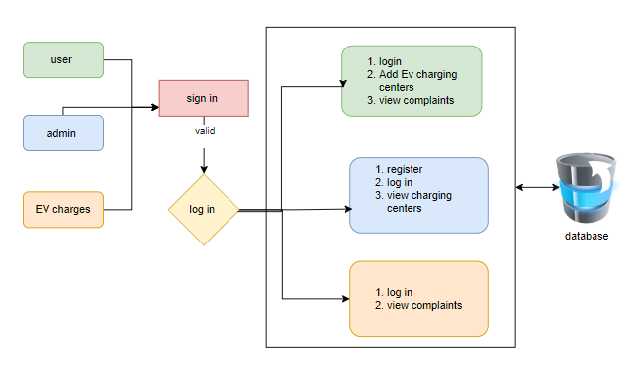

**CHAPTER - 10**

**SYSTEM STUDY AND TESTING**

**10.1 Feasibility study**

**FEASIBILITY STUDY**

The feasibility of the project is analyzed in this phase and business proposal is put forth with a very general plan for the project and some cost estimates. During system analysis the feasibility study of the proposed system is to be carried out. This is to ensure that the proposed system is not a burden to the company. For feasibility analysis, some understanding of the major requirements for the system is essential.

Three key considerations involved in the feasibility analysis are

* ECONOMICAL FEASIBILITY
* TECHNICAL FEASIBILITY
* SOCIAL FEASIBILITY

**ECONOMICAL FEASIBILITY**

This study is carried out to check the economic impact that the system will have on the organization. The amount of fund that the company can pour into the research and development of the system is limited. The expenditures must be justified. Thus, the developed system as well within the budget and this was achieved because most of the technologies used are freely available. Only the customized products had to be purchased.

**TECHNICAL FEASIBILITY**

This study is carried out to check the technical feasibility, that is, the technical requirements of the system. Any system developed must not have a high demand on the available technical resources. This will lead to high demands on the available technical resources. This will lead to high demands being placed on the client. The developed system must have a modest requirement, as only minimal or null changes are required for implementing this system.

**SOCIAL FEASIBILITY**

The aspect of study is to check the level of acceptance of the system by the user. This includes the process of training the user to use the system efficiently. The user must not feel threatened by the system, instead must accept it as a necessity. The level of acceptance by the users solely depends on the methods that are employed to educate the user about the system and to make him familiar with it. His level of confidence must be raised so that he is also able to make some constructive criticism, which is welcomed, as he is the final user of the system.

**SYSTEM TESTING**

The purpose of testing is to discover errors. Testing is the process of trying to discover every conceivable fault or weakness in a work product. It provides a way to check the functionality of components, sub-assemblies, assemblies and/or a finished product It is the process of exercising software with the intent of ensuring that the software system meets its requirements and user expectations and does not fail in an unacceptable manner. There are various types of tests. Each test type addresses a specific testing requirement.

**10.2 Types of test & Test Cases**

**UNIT TESTING**

Unit testing involves the design of test cases that validate that the internal program logic is functioning properly, and that program inputs produce valid outputs. All decision branches and internal code flow should be validated. It is the testing of individual software units of the application .it is done after the completion of an individual unit before integration. This is a structural testing, that relies on knowledge of its construction and is invasive. Unit tests perform basic tests at component level and test a specific business process, application, and/or system configuration. Unit tests ensure that each unique path of a business process performs accurately to the documented specifications and contains clearly defined inputs and expected results.

**INTEGRATION TESTING**

Integration tests are designed to test integrated software components to determine if they actually run as one program. Testing is event driven and is more concerned with the basic outcome of screens or fields. Integration tests demonstrate that although the components were individually satisfaction, as shown by successfully unit testing, the combination of components is correct and consistent. Integration testing is specifically aimed at exposing the problems that arise from the combination of components.

**FUNCTIONAL TEST**

Functional tests provide systematic demonstrations that functions tested are available as specified by the business and technical requirements, system documentation, and user manuals.

Functional testing is centred on the following items:

Valid Input : identified classes of valid input must be accepted.

Invalid Input : identified classes of invalid input must be rejected.

Functions : identified functions must be exercised.

Output : identified classes of application outputs must be exercised.

Systems/Procedures : interfacing systems or procedures must be invoked. Organization and preparation of functional tests is focused on requirements, key functions, or special test cases. In addition, systematic coverage pertaining to identify Business process flows; data fields, predefined processes, and successive processes must be considered for testing. Before functional testing is complete, additional tests are identified and the effective value of current tests is determined.

**SYSTEM TEST**

System testing ensures that the entire integrated software system meets requirements. It tests a configuration to ensure known and predictable results. An example of system testing is the configuration-oriented system integration test. System testing is based on process descriptions and flows, emphasizing pre-driven process links and integration points.

**WHITE BOX TESTING**

White Box Testing is a testing in which in which the software tester has knowledge of the inner workings, structure and language of the software, or at least its purpose. It is purpose. It is used to test areas that cannot be reached from a black box level.

**BLACK BOX TESTING**

Black Box Testing is testing the software without any knowledge of the inner workings, structure or language of the module being tested. Black box tests, as most other kinds of tests, must be written from a definitive source document, such as specification or requirements document, such as specification or requirements document. It is a testing in which the software under test is treated, as a black box. you cannot “see” into it. The test provides inputs and responds to outputs without considering how the software works.

**UNIT TESTING:**

Unit testing is usually conducted as part of a combined code and unit test phase of the software lifecycle, although it is not uncommon for coding and unit testing to be conducted as two distinct phases.

**Test strategy and approach**

Field testing will be performed manually and functional tests will be written in detail.

**Test objectives**

* All field entries must work properly.
* Pages must be activated from the identified link.
* The entry screen, messages and responses must not be delayed.

**Features to be tested**

* Verify that the entries are of the correct format
* No duplicate entries should be allowed
* All links should take the user to the correct page.

# INTEGRATION TESTINGSS

Software integration testing is the incremental integration testing of two or more integrated software components on a single platform to produce failures caused by interface defects.

The task of the integration test is to check that components or software applications, e.g., components in a software system or – one step up – software applications at the company level – interact without error.

**Test Results:** All the test cases mentioned above passed successfully. No defects encountered.

**ACCEPTANCE TESTING**

User Acceptance Testing is a critical phase of any project and requires significant participation by the end user. It also ensures that the system meets the functional requirements.

|  |  |  |  |  |  |  |  |
| --- | --- | --- | --- | --- | --- | --- | --- |
| Test case id | Test Scenario | Test Steps | Prerequisites | Test Data | Expected result | Actual result | Test status |
| **#CVD001** | To authenticate a successful signup with user data | * User navigate the signup page * Enter the valid user data * Click on signup button | User data | Username  Password  Mobile  Email  location | When the user submits the user data, data should be store in database successfully | As Expected, | Pass |
| **#CVD002** | To authenticate a successful login with user data | * User navigate the login page * Enter the valid username, password * Click on login button | Username, password | Username, password | When the user submits the user data, data should be authenticate successfully | As Expected, | Pass |

**TESTING CASES**

**CHAPTER – 11**

**FUTURE ENHANCEMENT**

Future enhancements to the "Data Challenges for E-Mobility" project could focus on expanding the platform's capabilities and improving its integration with emerging technologies in the e-mobility sector. One potential enhancement is the inclusion of real-time charging station availability and dynamic pricing models based on demand, allowing users to view current availability and adjust their charging plans accordingly. The system could also integrate with advanced navigation tools to provide users with optimal routes based on charging station locations and the vehicle's remaining battery life. To enhance user experience, features like EV-specific parking spot reservations and notifications for charging completion could be incorporated.

Moreover, the platform could be expanded to support multi-modal transportation systems, such as e-bikes, scooters, and public electric transport, allowing users to view all electric mobility options in a single interface. As electric vehicle technology advances, the platform could incorporate smart grid integration, enabling EV charging stations to interact dynamically with the power grid, optimizing energy usage and reducing costs during peak demand times. Incorporating machine learning algorithms to predict and manage charging patterns based on user behavior and historical data could further improve the efficiency of the network.

**CHAPTER – 12**

**CONCLUSION**

The "Data Challenges for E-Mobility" project addresses critical issues in the growing electric vehicle (EV) sector, particularly in the management and optimization of charging infrastructure. By creating an integrated platform that connects users, administrators, and charging center operators, the project aims to enhance the efficiency, accessibility, and reliability of EV charging services. Through the Admin, User, and EV Center modules, the system ensures smooth communication, timely complaint resolution, and better management of charging stations. These improvements ultimately contribute to a better user experience and greater adoption of electric vehicles, helping to advance the global transition to sustainable mobility solutions. The platform not only tackles operational inefficiencies but also supports data-driven decision-making, enabling administrators to monitor usage trends and address issues proactively. This streamlined approach helps enhance service delivery and ensures that EV owners have access to the charging infrastructure they need, when they need it. As the EV market continues to expand, this system provides a crucial tool for managing the complex dynamics of the evolving e-mobility landscape.

**REFERENCES**

* Zhang, Y., Wang, X., & Chen, L. (2021). "Data-Driven Optimization for EV Charging Infrastructure." *Journal of Sustainable Energy Systems*, 14(3), 245-259.
* Sharma, R., & Gupta, S. (2020). "Complaint Management Systems in Smart Cities." *International Journal of Urban Computing*, 12(1), 78-91.
* Li, J., Zhao, M., & Feng, Q. (2022). "E-Mobility and Digital Platforms: Enabling Sustainable Transportation." *Journal of Smart Transportation Systems*, 19(4), 134-148.
* Kumar, A., & Singh, P. (2019). "Challenges in EV Adoption: A Data Perspective." *Journal of Renewable Mobility Research*, 7(2), 56-67.
* Müller, K., & Schmidt, H. (2023). "Sustainable Mobility through Efficient EV Charging Networks." *Journal of Green Transportation Solutions*, 20(1), 92-108.
* Johnson, P., & Pereira, R. (2020). "User-Centric Design in Electric Vehicle Ecosystems." *Journal of Human-Centered Computing*, 15(5), 231-244.
* Smith, T., & Johnson, K. (2021). "Optimizing Electric Vehicle Infrastructure for Urban Mobility." *Journal of Urban Transport Systems*, 16(2), 87-103.
* Chen, L., & Wei, M. (2020). "Data-Driven Innovations in Electric Mobility Ecosystems." *International Journal of Sustainable Transportation*, 13(4), 210-225.
* Rodriguez, P., & Martinez, J. (2022). "Real-Time Complaint Resolution in Electric Mobility Systems." *Journal of Smart City Applications*, 10(3), 150-167.
* Patel, R., & Sharma, A. (2023). "Scalable Architectures for EV Charging Station Management." *Journal of Renewable Energy Systems*, 21(1), 45-61.

**APPENDIX-A**

**PSEUDOCODE**

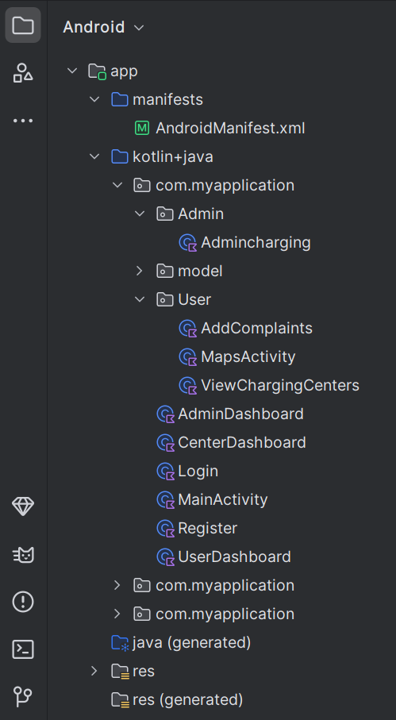

**APPENDIX-B**

**SCREENSHOTS**

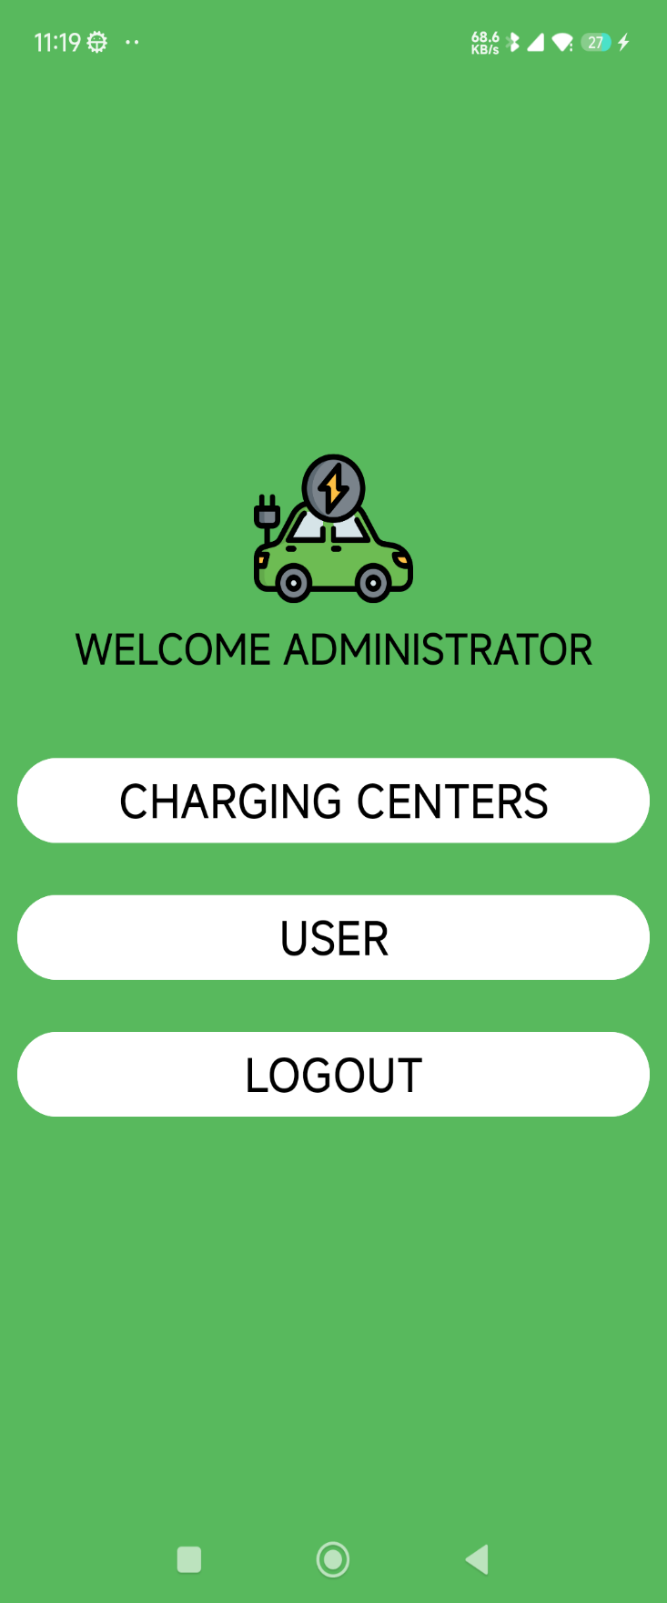

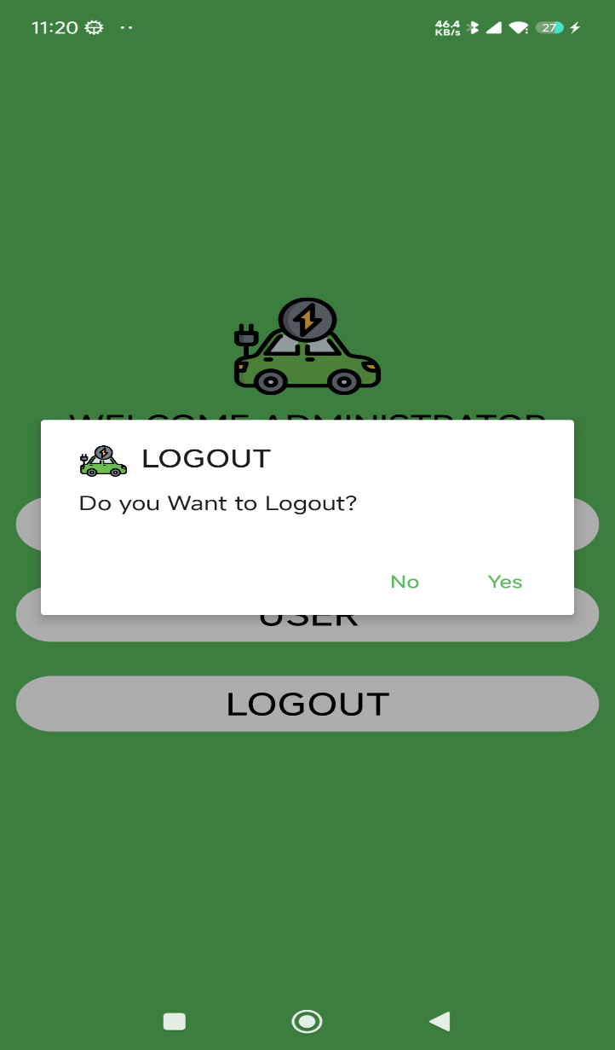

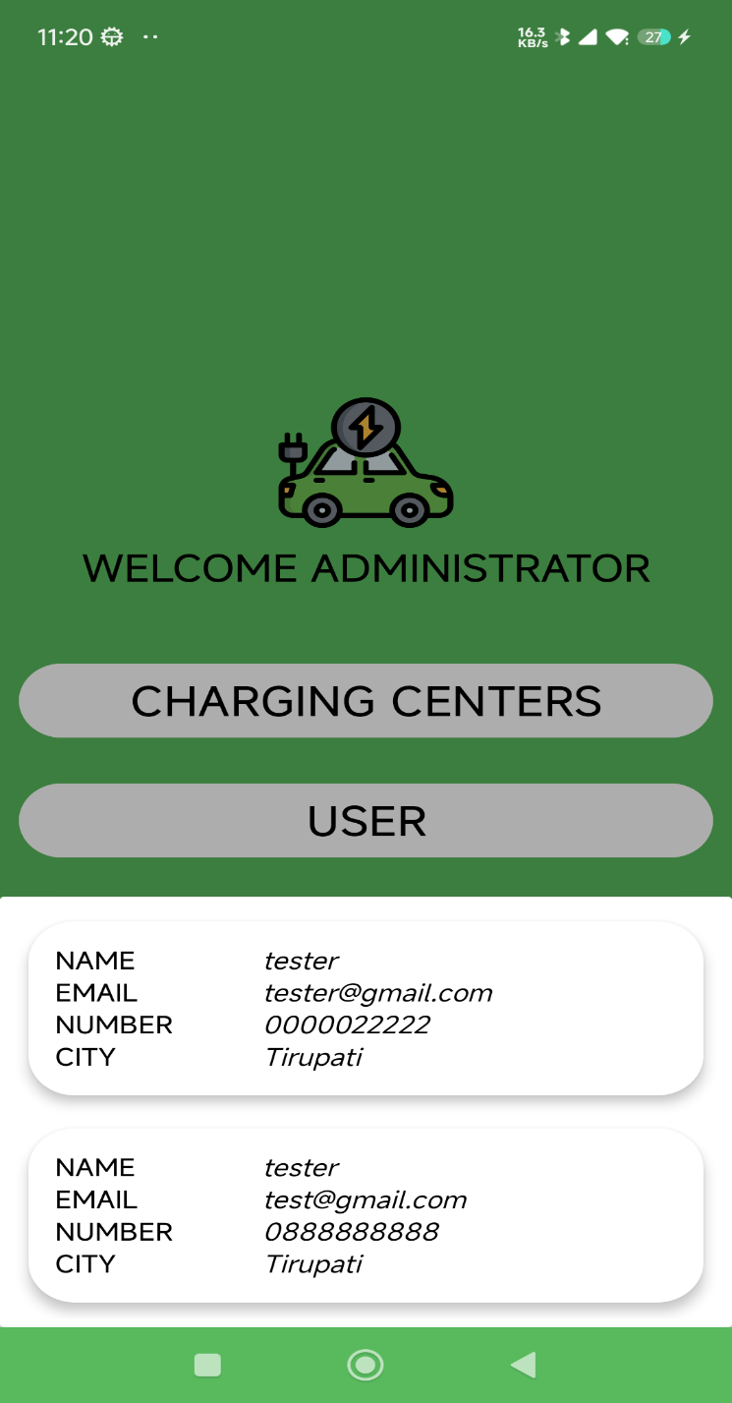

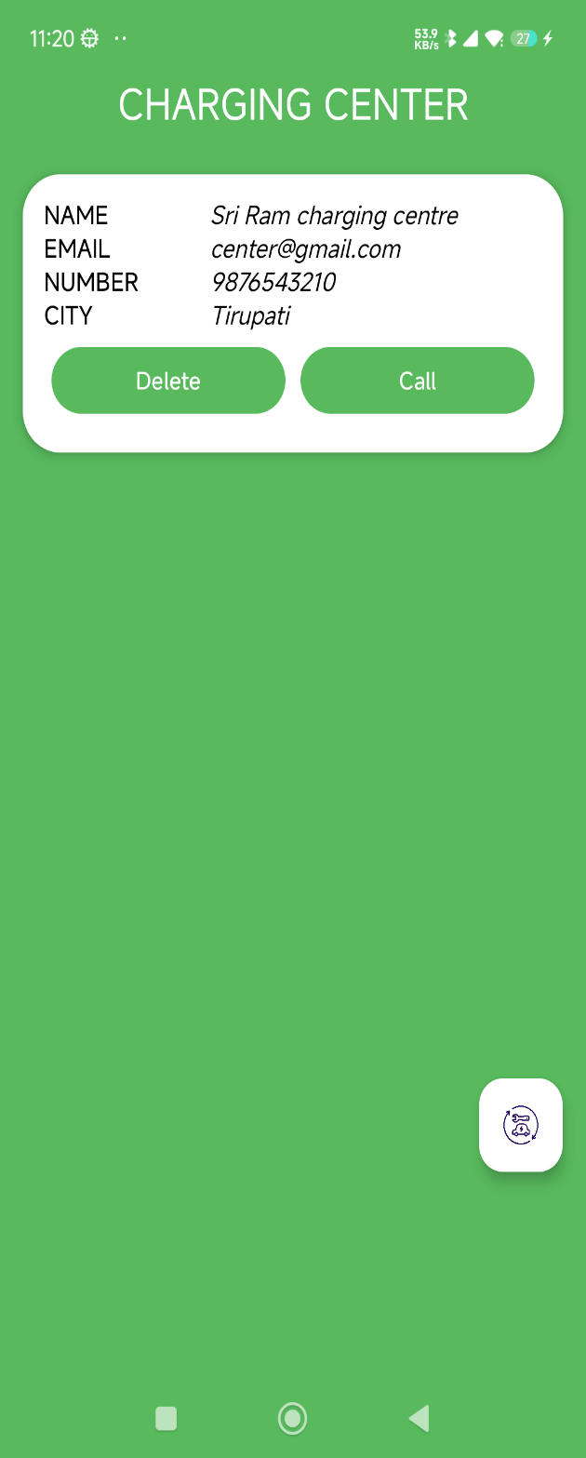

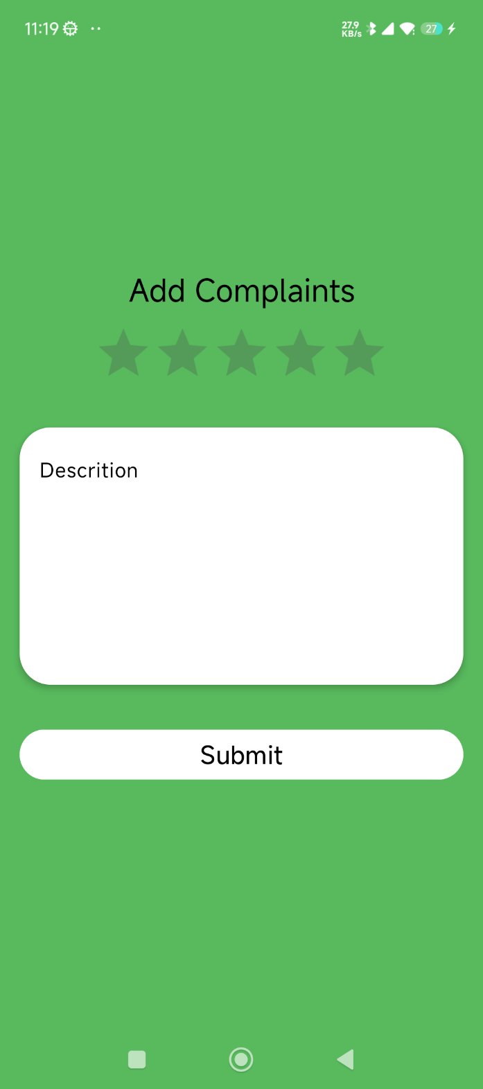

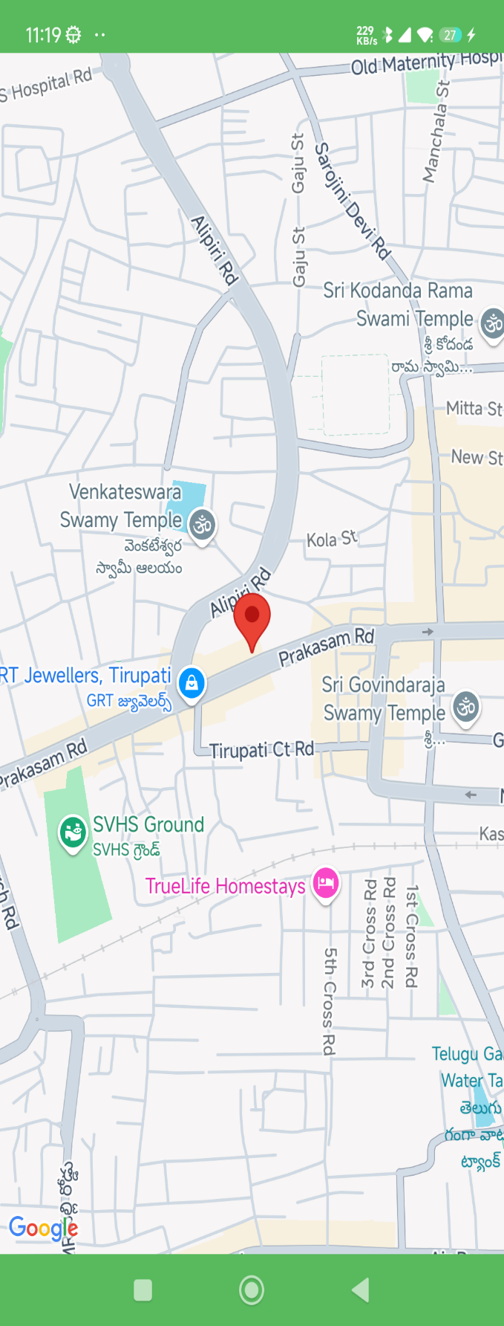

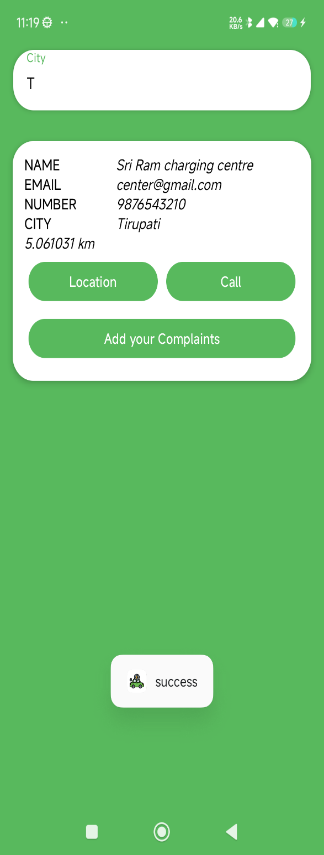

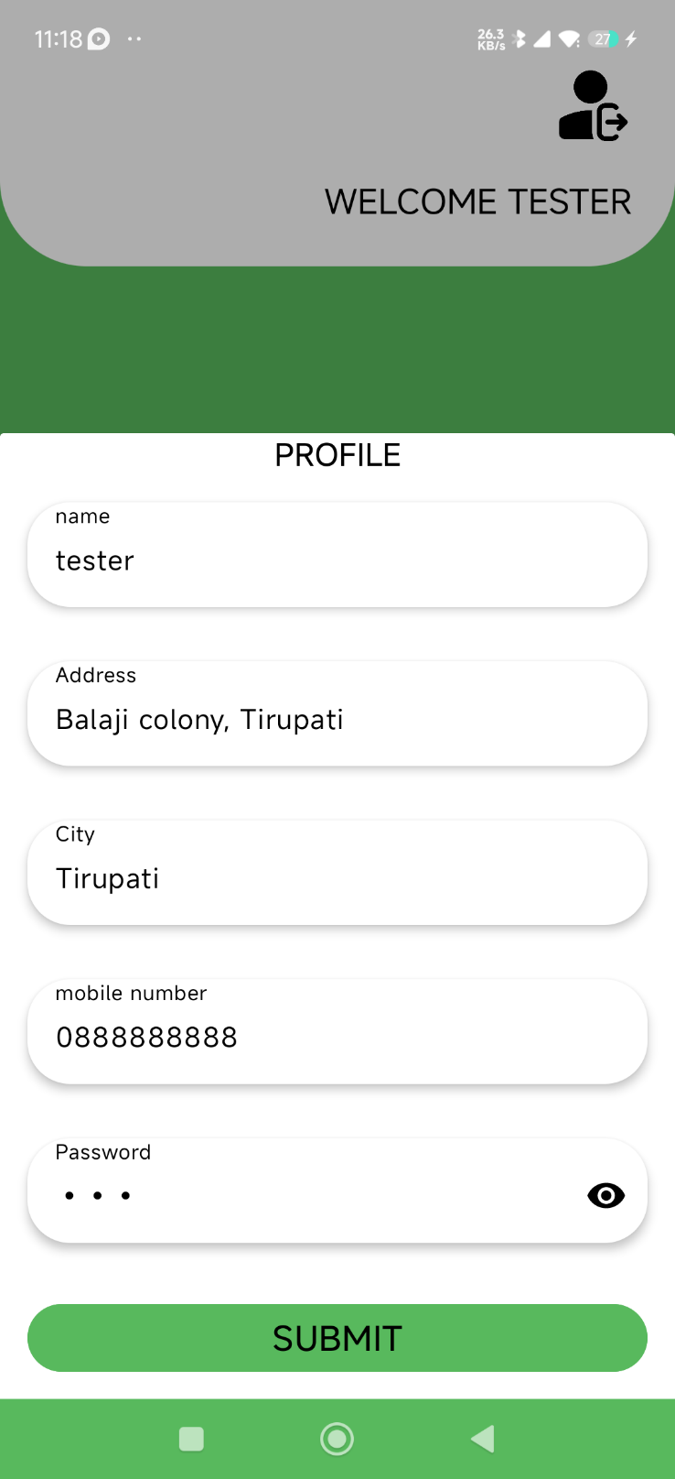

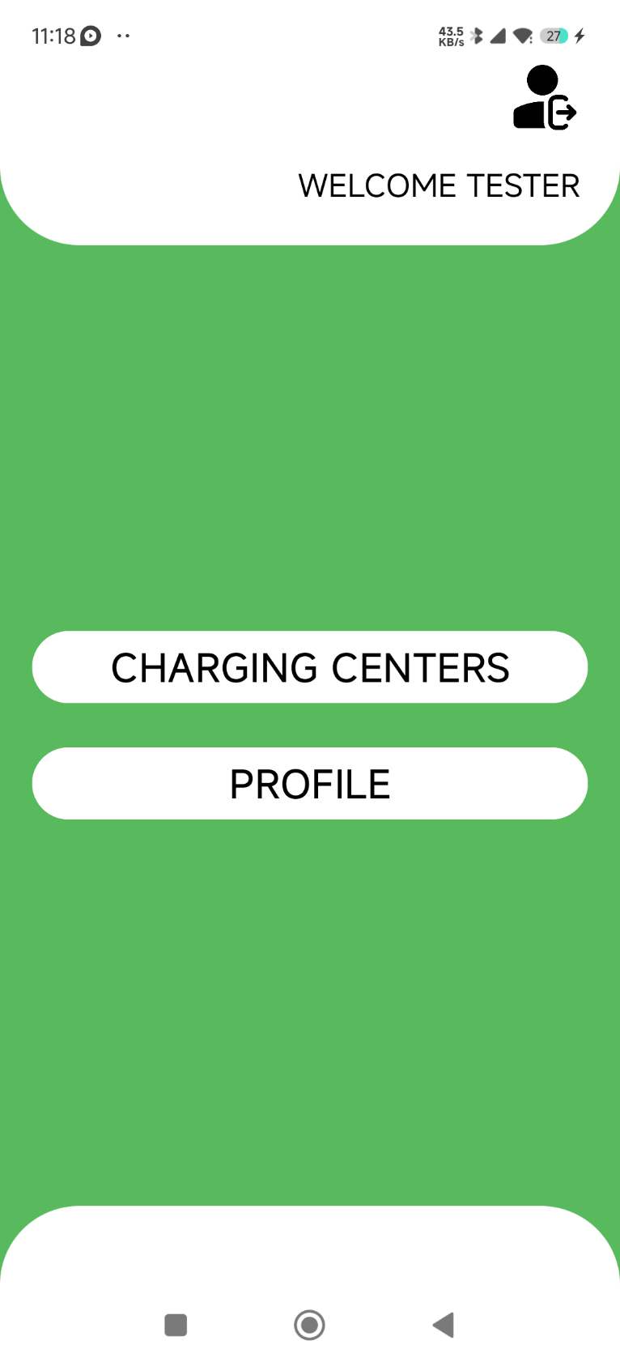

Figure 9 User Dashboard

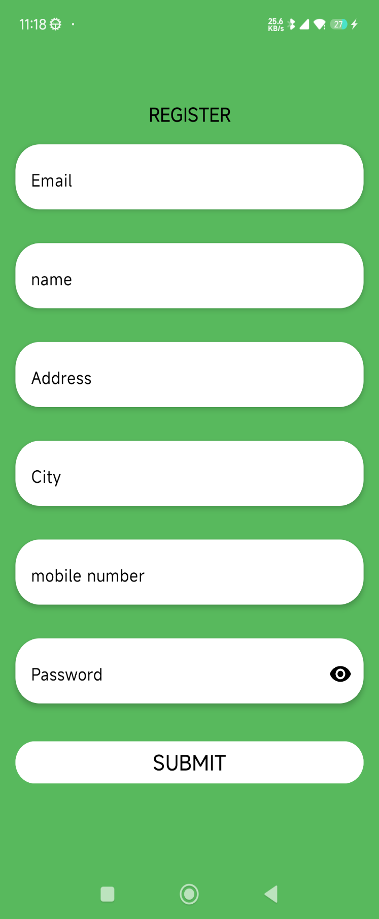

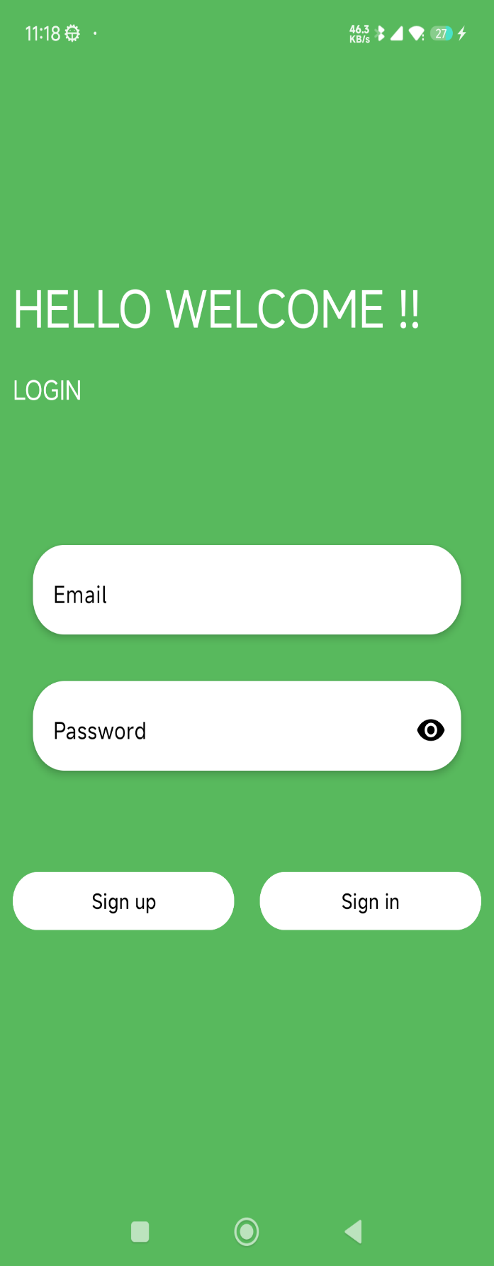





**APPENDIX-C**

**ENCLOSURES**

**1. Journal publication/Conference Paper Presented Certificates of all students.**

**2. Include certificate(s) of any Achievement/Award won in any project-related event.**

**3. Similarity Index / Plagiarism Check report clearly showing the Percentage (%). No need for a page-wise explanation.**

**4.** **Details of mapping the project with the Sustainable Development Goals (SDGs).**